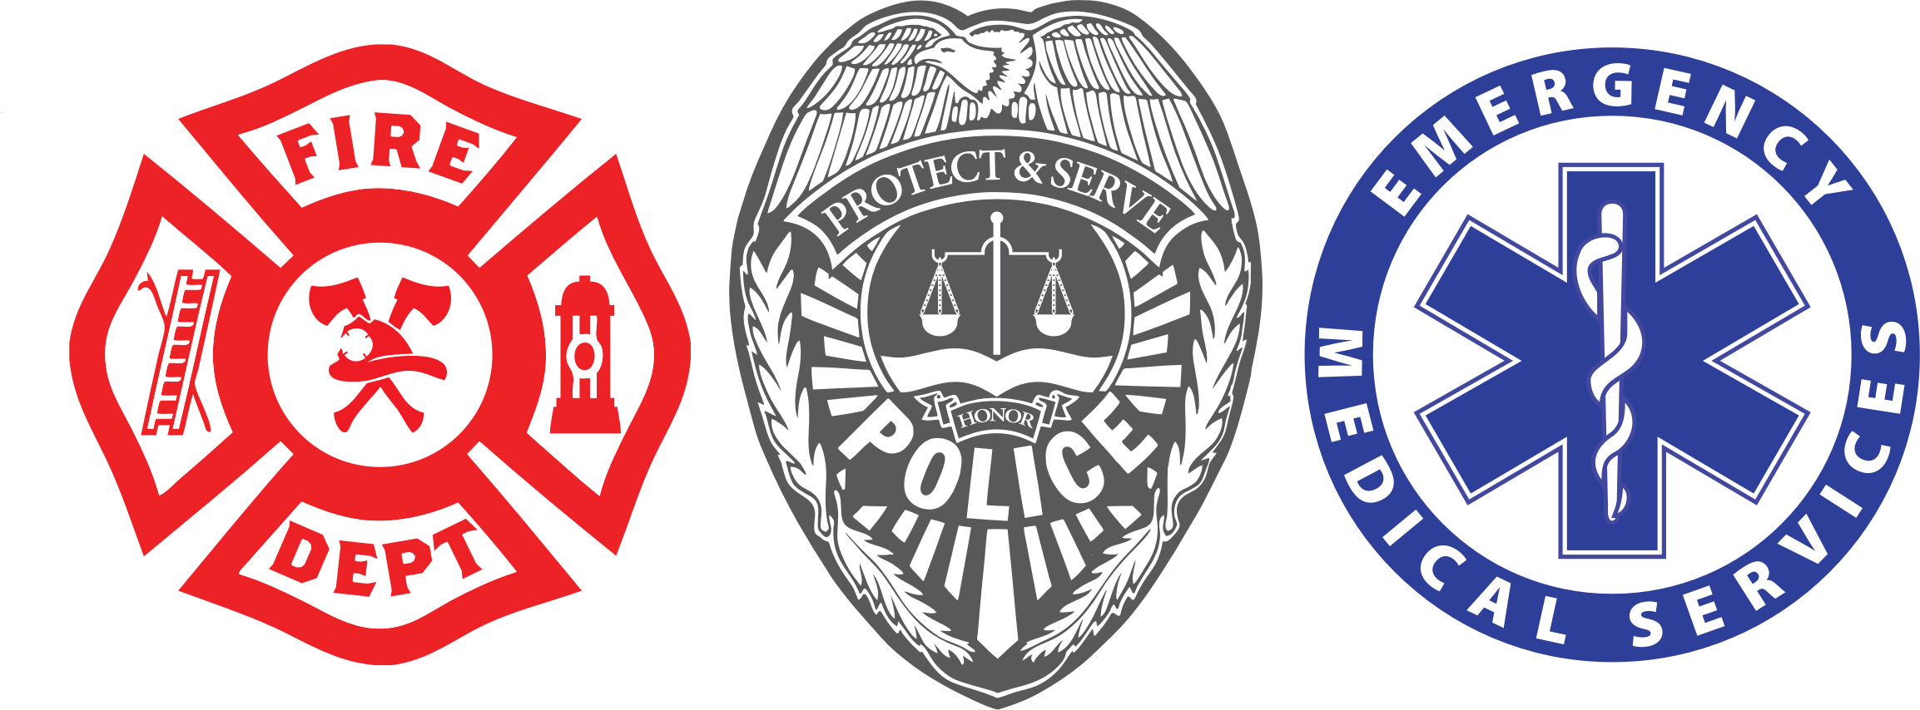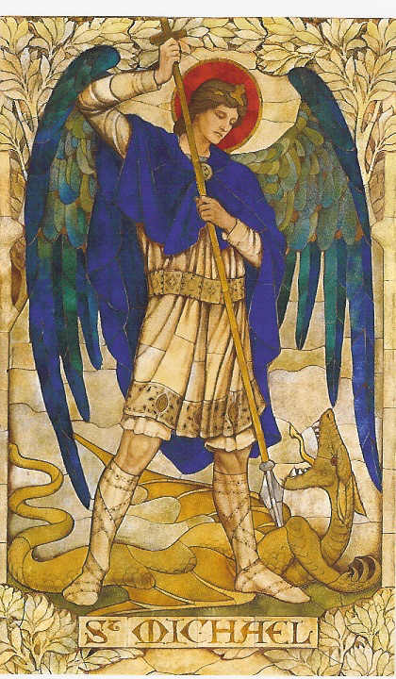

11:00 AM

September 24

Sunday

# A celebration of the Feast of St. Michael the Archangel, patron of police officers, firefighters and emergency workers, and a thank you to these professionals who help keep us safe. Father Terrence Hayes, MPD Community Chaplain will preside and Father Daniel Griffith will preach.

* First responders Mass

Our Lady of Lourdes Catholic Church

Reception to follow. Everyone is welcome!